Reverse bit

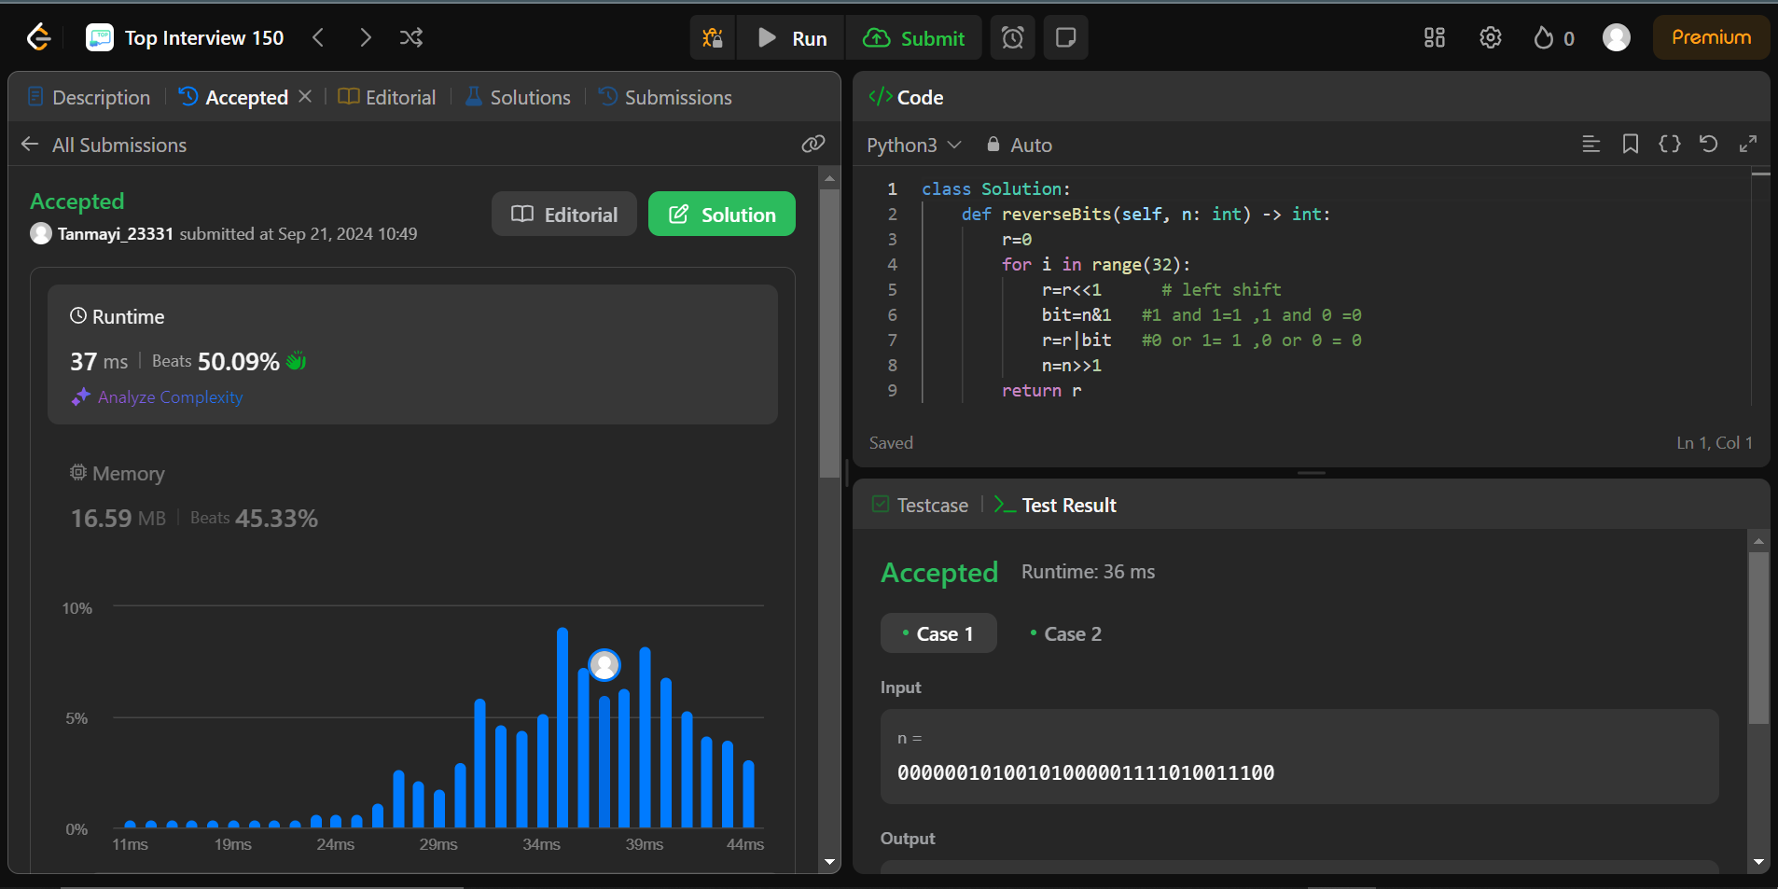

Code:

n=00000010100101000001111010011100

r=0

for i in range(32):

r=r<<1 # left shift

bit=n&1 #1 and 1=1 ,1 and 0 =0

r=r|bit #0 or 1= 1 ,0 or 0 = 0

n=n>>1 # right shift

print(r)

Explain:

r is the reverse bit variable. here we are running a loop for 32 time where each time the r is left shifted that means a 0 is added at the end .now r is 00 then bit is a new variable to get the last bit .we get the last bit by using and operator .as if n is the last bit

if n=0 if n=1

0 &1=0 1&1=1

Now to add it to the reverse we are using the or operator.

If bit =0 if bit =1

0|0=0 1|1=1

Once this is done we are moving to the next bit by using the right shift .which remove the last bit .

Example: 100>>1=10 and 100<<1=1000